**PROGRAM:**

from collections import deque

def bfs(start_node, stop_node):

open_set = deque([start_node])

visited = [0] * n

parents = {start_node: None}

while open_set:

current_node = open_set.popleft()

if index_node[current_node] == stop_node:

path = []

while current_node is not None:

path.append(index_node[current_node])

current_node = parents[current_node]

path.reverse()

print('Path found:', ' -> '.join(path))

return path

visited[current_node] = 1

for i in range(n):

if nodes[current_node][i] == 1 and not visited[i]:

open_set.append(i)

visited[i] = 1

parents[i] = current_node

print('Path does not exist!')

return None

n = 20

nodes = [[0 for _ in range(n)] for _ in range(n)]

edges = [

('ORADEA', 'ZERIND'),

('ORADEA', 'SIBIU'),

('ZERIND', 'ARAD'),

('ARAD', 'SIBIU'),

('ARAD', 'TIMISOARA'),

('TIMISOARA', 'LUGOJ'),

('LUGOJ', 'MEHADIA'),

('MEHADIA', 'DROBETA'),

('DROBETA', 'CRAIOVA'),

('CRAIOVA', 'PITESTI'),

('CRAIOVA', 'RIMNICU_VILCEA'),

('PITESTI', 'BUCHAREST'),

('BUCHAREST', 'GIURGIU'),

('BUCHAREST', 'URZICENI'),

('URZICENI', 'HIRSOVA'),

('HIRSOVA', 'EFORIE'),

('URZICENI', 'VASLUI'),

('VASLUI', 'IASI'),

('IASI', 'NEAMT'),

('BUCHAREST', 'FAGARAS'),

('SIBIU', 'FAGARAS'),

('SIBIU', 'RIMNICU_VILCEA')

]

node_index = {

'ORADEA': 0,

'ZERIND': 1,

'ARAD': 2,

'TIMISOARA': 3,

'LUGOJ': 4,

'MEHADIA': 5,

'DROBETA': 6,

'CRAIOVA': 7,

'PITESTI': 8,

'BUCHAREST': 9,

'GIURGIU': 10,

'URZICENI': 11,

'HIRSOVA': 12,

'EFORIE': 13,

'VASLUI': 14,

'IASI': 15,

'NEAMT': 16,

'FAGARAS': 17,

'SIBIU': 18,

'RIMNICU_VILCEA': 19

}

index_node = {v: k for k, v in node_index.items()}

for edge in edges:

x, y = node_index[edge[0]], node_index[edge[1]]

nodes[x][y] = nodes[y][x] = 1

start_node = node_index['ARAD']

stop_node = 'BUCHAREST'

bfs(start_node, stop_node)

**OUTPUT:**

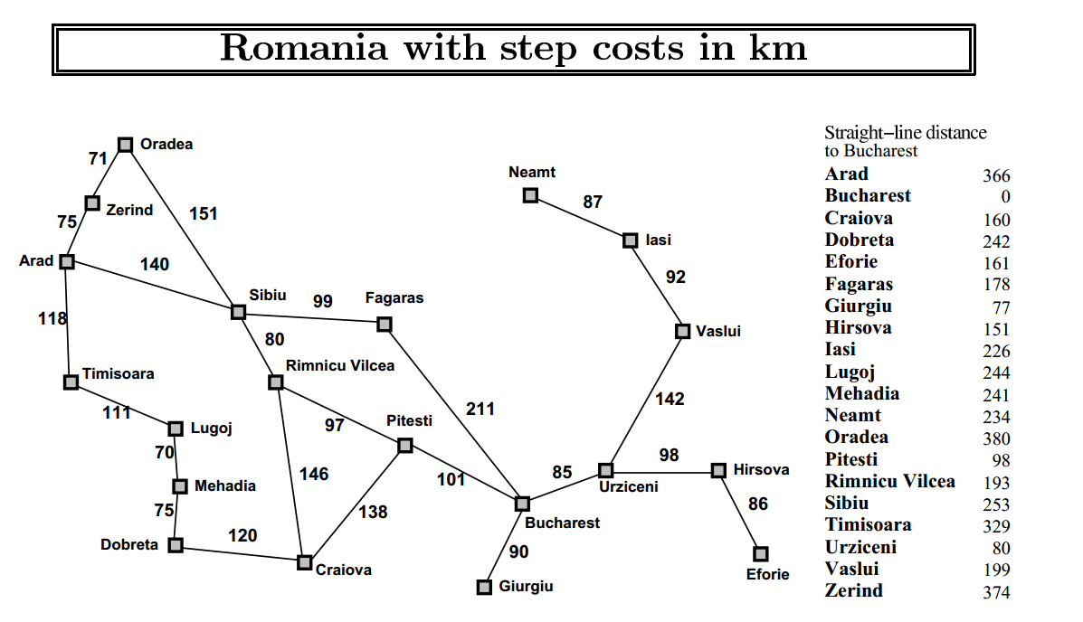

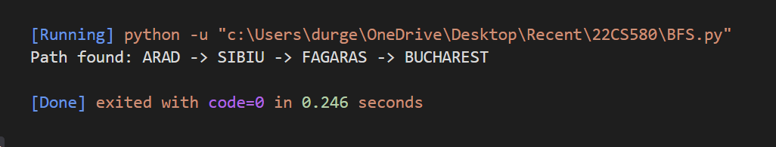

**PROGRAM:**

def dfs(x, stop_node, path):

path.append(index_node[x])

if index_node[x] == stop_node:

print('Path found:', ' -> '.join(path))

return True

visited[x] = 1

for i in range(n):

if nodes[x][i] == 1 and not visited[i]:

if dfs(i, stop_node, path):

return True

path.pop()

return False

n = 20

nodes = [[0 for _ in range(n)] for _ in range(n)]

edges = [

('ORADEA', 'ZERIND'),

('ORADEA', 'SIBIU'),

('ZERIND', 'ARAD'),

('ARAD', 'SIBIU'),

('ARAD', 'TIMISOARA'),

('TIMISOARA', 'LUGOJ'),

('LUGOJ', 'MEHADIA'),

('MEHADIA', 'DROBETA'),

('DROBETA', 'CRAIOVA'),

('CRAIOVA', 'PITESTI'),

('CRAIOVA', 'RIMNICU_VILCEA'),

('PITESTI', 'BUCHAREST'),

('BUCHAREST', 'GIURGIU'),

('BUCHAREST', 'URZICENI'),

('URZICENI', 'HIRSOVA'),

('HIRSOVA', 'EFORIE'),

('URZICENI', 'VASLUI'),

('VASLUI', 'IASI'),

('IASI', 'NEAMT'),

('BUCHAREST', 'FAGARAS'),

('SIBIU', 'FAGARAS'),

('SIBIU', 'RIMNICU_VILCEA')

]

node_index = {

'ORADEA': 0,

'ZERIND': 1,

'ARAD': 2,

'TIMISOARA': 3,

'LUGOJ': 4,

'MEHADIA': 5,

'DROBETA': 6,

'CRAIOVA': 7,

'PITESTI': 8,

'BUCHAREST': 9,

'GIURGIU': 10,

'URZICENI': 11,

'HIRSOVA': 12,

'EFORIE': 13,

'VASLUI': 14,

'IASI': 15,

'NEAMT': 16,

'FAGARAS': 17,

'SIBIU': 18,

'RIMNICU_VILCEA': 19

}

index_node = {v: k for k, v in node_index.items()}

for edge in edges:

x, y = node_index[edge[0]], node_index[edge[1]]

nodes[x][y] = nodes[y][x] = 1

visited = [0] * n

start_node = 'ARAD'

stop_node = 'BUCHAREST'

path = []

if not dfs(node_index[start_node], stop_node, path):

print('Path does not exist!')

**OUTPUT:**



